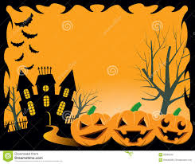
Come Join our ReVOLTing Gang
For a
Spooky Halloween Lunch
At
The Village Hall
Linton
On
Saturday 31st October
At
12.30
Tickets £5 Adult & £2.50 Child
Available from The Post Office, Linton
The Alma, Linton
www.lintonvillage.com

