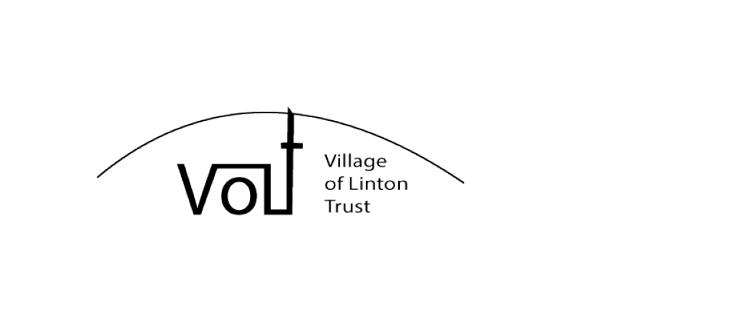

Single Donation Gift Aid Declaration

Please treat my payment of £_______________ to the Village of Linton Trust, as a Gift Aid Donation.

I confirm I have paid, or will pay, an amount of income tax and/or capital gains tax, for the current tax year (6th April to 5th April), that is at least equal to the amount of tax that all the charities and Community Amateur Sports Clubs that I donate to will reclaim on my gifts for the current tax year.
I understand that other taxes such as VAT and Council Tax do not qualify.
I understand that the charity will reclaim 25p on every £1 that I have given.

Signature: Date:

Name (Print):

Home Address:

Please notify the Treasurer of VoLT if you change address /wish to cancel / no longer pay sufficient tax and/ or capital gains tax to confirm this Gift Aid Declaration.

