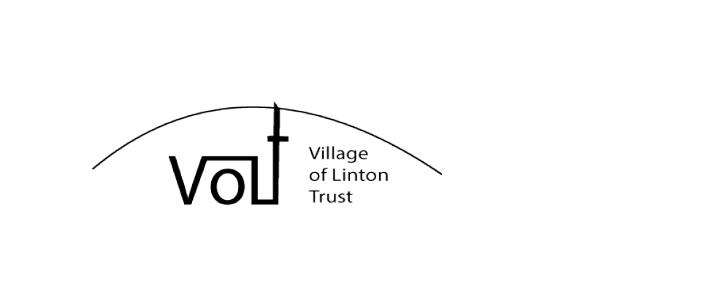

Village of Linton Trust – Membership Form 2015
I/We wish to join the Village of Linton Trust (VoLT)

Main contact information
Name of main contact:
Address:
Post Code:
Landline Number:* Mobile Number:*
Email:*

Additional members at the same address
First Name Last Name Date of Birth (under 16’s only)

VoLT will use this information only to contact you about membership, fund raising events and working parties. Please give an order of preference to the items marked * above.

Payment
A single adult membership subscription for 2015/16 is £5.00, members under 16 are free.
Subscription for ___________ adult members (£5.00 each) £______________
Voluntary donation** £______________
Total payment £______________

** The use of donations will be at the discretion of the trustees for the purposes of the trust, unless the donor provides a letter indicating otherwise. If you would like VoLT to be able to claim the tax back on your total payment, please complete the VoLT Gift Aid Declaration form.
I/We wish to pay by: (delete those which are NOT applicable)
- cheque- please make payable to Village of Linton Trust
- cash
- standing order - please complete the form
A payment receipt on behalf of VoLT will be given, or delivered to the main contact address.

PLEASE RETURN YOUR FORM AND MEMBERSHIP FEE TO MR. SQUIRES AT LINTON POST OFFICE.
IT WILL THEN BE PASSED TO VOLT TRUSTEES.
THANK YOU.

