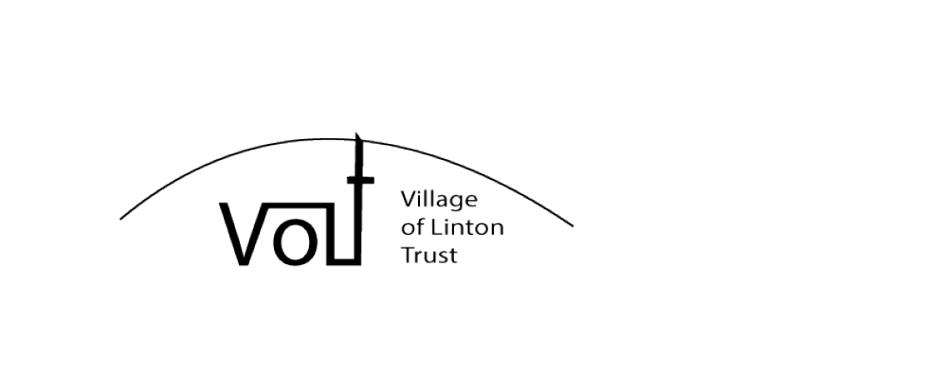

DID YOU KNOW THAT THE VILLAGE OF LINTON HAS A NEW CHARITY?
DID YOU KNOW THAT THE ‘VILLAGE OF LINTON TRUST’ NEEDS YOU?

The constitution states that:
- The primary purpose of the charity is to provide financial and practical assistance to help conserve and maintain Linton church and its grounds.
- In addition, it will seek to help maintain the heritage and appearance of Linton village in ways that are compatible with the primary purpose.

Annual membership is open to everyone and costs just £5.00 with under 16s free. Please join as soon as you can as your support will make an immediate and positive difference.
We hope that VoLT will appeal to all: church-goers, pub-goers, village hall fans, village fans – essentially any one at any age who is interested in maintaining the heritage of Linton village with our beautiful, medieval church at its centre. Some exciting fund-raising and social events are already planned for 2015. Please look out for updates in the Chimes magazine and tell your friends and neighbours about the Village of Linton Trust.

For more information, please pick up a constitution and a membership form from: The Alma Inn, St Mary’s Church or Linton Post Office.

Mr Brian Squires at Linton Post Office will kindly accept completed membership forms.
Any questions and/or comments may be sent to secretary@villageoflintontrust.co.uk.

THANK YOU

